Darius Quick
7/17/25
Module 3 Assignment
S3 Showing Angular Files
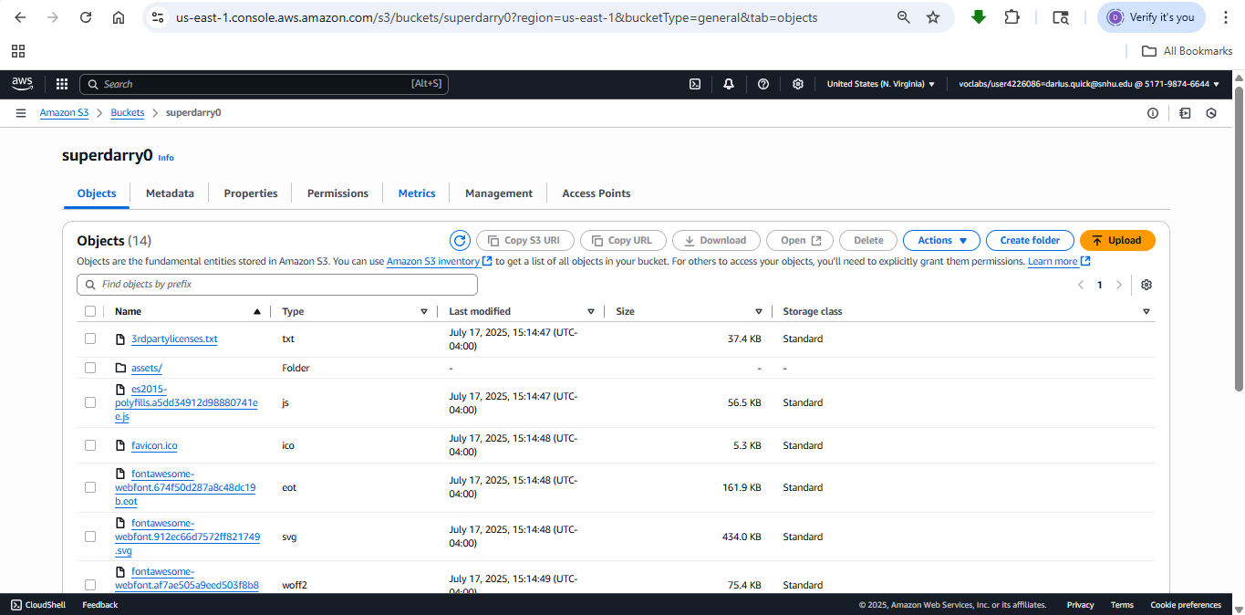
S3 Block Public Access Off
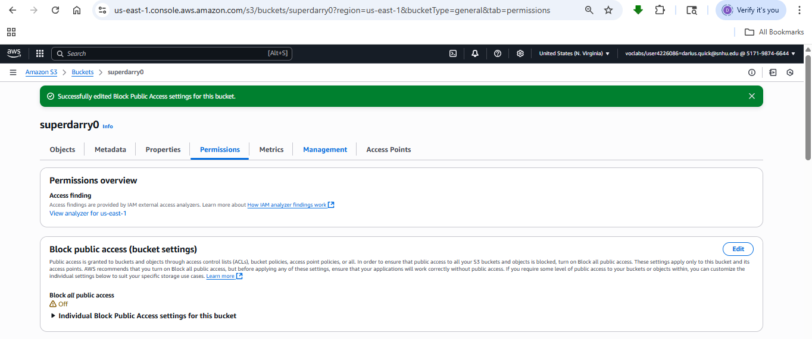
S3 JSON Policy 1
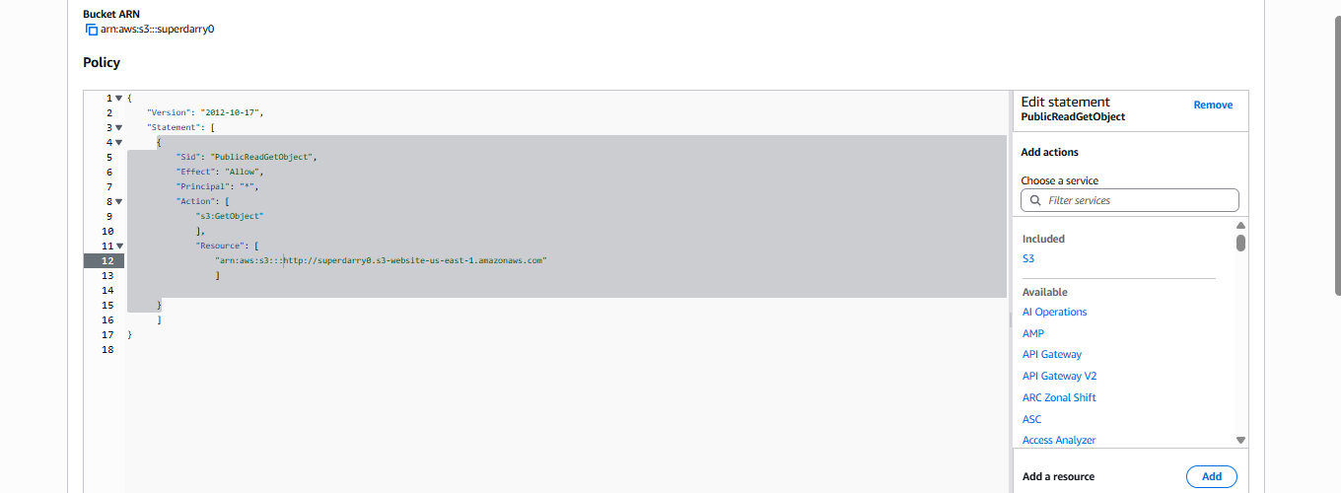
S3 JSON Policy 2
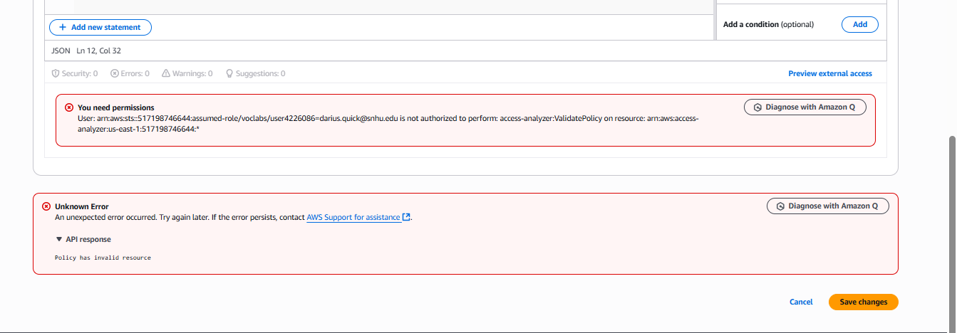
Screenshot after I wasn’t able to save my JSON Policy due to not having authorization
